Example Azure infrastructure walkthrough for Windows VMs

This article is part of a wider series to provide you with design considerations and guidelines as you build out an application infrastructure in Azure. You can [view the additional topics in the series](https://docs.microsoft.com/en-in/azure/virtual-machines/windows/infrastructure-example#next-steps). Although you can quickly build a dev/test environment in Azure, there are additional considerations when implementing a production-ready, highly available, and secure environment.

This article walks through building out an example application infrastructure. We detail designing an infrastructure for a simple online store that brings together all the guidelines and decisions around naming conventions, availability sets, virtual networks and load balancers, and actually deploying your virtual machines (VMs).

Example workload

Adventure Works Cycles wants to build an online store application in Azure that consists of:

* Two IIS servers running the client front-end in a web tier
* Two IIS servers processing data and orders in an application tier
* Two Microsoft SQL Server instances with AlwaysOn availability groups (two SQL Servers and a majority node witness) for storing product data and orders in a database tier
* Two Active Directory domain controllers for customer accounts and suppliers in an authentication tier
* All the servers are located in two subnets:
  + a front-end subnet for the web servers
  + a back-end subnet for the application servers, SQL cluster, and domain controllers

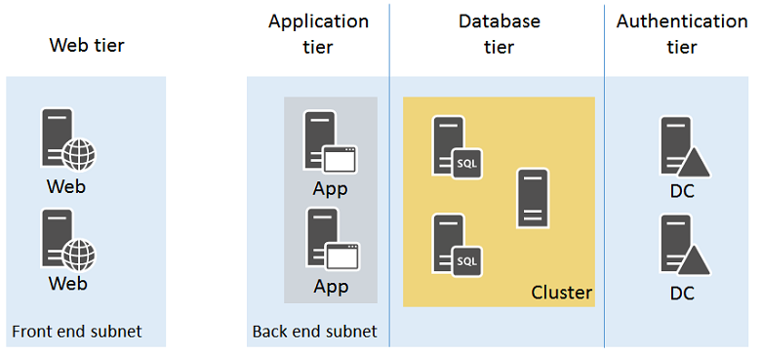

Incoming secure web traffic must be load-balanced among the web servers as customers browse the online store. Order processing traffic in the form of HTTP requests from the web servers must be balanced among the application servers. Additionally, the infrastructure must be designed for high availability.

The resulting design must incorporate:

* An Azure subscription and account
* A single resource group
* Azure Managed Disks
* A virtual network with two subnets
* Availability sets for the VMs with a similar role
* Virtual machines

All the above follow these naming conventions:

* Adventure Works Cycles uses **[IT workload]-[location]-[Azure resource]** as a prefix
  + For this example, "**azos**" (Azure Online Store) is the IT workload name and "**use**" (East US 2) is the location
* Virtual networks use AZOS-USE-VN**[number]**
* Availability sets use azos-use-as-**[role]**
* Virtual machine names use azos-use-vm-**[vmname]**

Azure subscriptions and accounts

Adventure Works Cycles is using their Enterprise subscription, named Adventure Works Enterprise Subscription, to provide billing for this IT workload.

Storage

Adventure Works Cycles determined that they should use Azure Managed Disks. When creating VMs, both storage available storage tiers are used:

* **Standard storage** for the web servers, application servers, and domain controllers and their data disks.
* **Premium storage** for the SQL Server VMs and their data disks.

Virtual network and subnets

Because the virtual network does not need ongoing connectivity to the Adventure Work Cycles on-premises network, they decided on a cloud-only virtual network.

They created a cloud-only virtual network with the following settings using the Azure portal:

* Name: AZOS-USE-VN01
* Location: East US 2
* Virtual network address space: 10.0.0.0/8
* First subnet:
  + Name: FrontEnd
  + Address space: 10.0.1.0/24
* Second subnet:
  + Name: BackEnd
  + Address space: 10.0.2.0/24

Availability sets

To maintain high availability of all four tiers of their online store, Adventure Works Cycles decided on four availability sets:

* **azos-use-as-web** for the web servers
* **azos-use-as-app** for the application servers
* **azos-use-as-sql** for the SQL Servers
* **azos-use-as-dc** for the domain controllers

Virtual machines

Adventure Works Cycles decided on the following names for their Azure VMs:

* **azos-use-vm-web01** for the first web server
* **azos-use-vm-web02** for the second web server
* **azos-use-vm-app01** for the first application server
* **azos-use-vm-app02** for the second application server
* **azos-use-vm-sql01** for the first SQL Server server in the cluster
* **azos-use-vm-sql02** for the second SQL Server server in the cluster
* **azos-use-vm-dc01** for the first domain controller
* **azos-use-vm-dc02** for the second domain controller

Here is the resulting configuration.

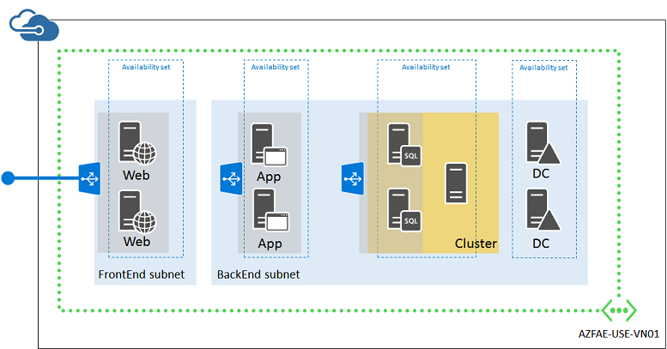

This configuration incorporates:

* A cloud-only virtual network with two subnets (FrontEnd and BackEnd)
* Azure Managed Disks with both Standard and Premium disks
* Four availability sets, one for each tier of the online store
* The virtual machines for the four tiers
* An external load balanced set for HTTPS-based web traffic from the Internet to the web servers
* An internal load balanced set for unencrypted web traffic from the web servers to the application servers
* A single resource group